**Stamford University Bangladesh**

Department of Computer Science & Engineering



Online Chocolate shop Management System

Software Engineering (CSI 332)

Primary Proposal & Feasibility Analysis

Presented By : Crazy Engineers

Submitted By:

* Md Nazim Uddin CSE 063 07429
* Priyanka Rani Satu CSE 063 07380
* Md. Naeemul Hasan CSE 063 07438
* Janith Sultana CSE 063 07477

# **Introduction:**

The project super shop chocolate management system deals with the automation of supermarket. It includes both sales and purchase of items. This project is developed with the objective of making the system reliable, easier, fast, and informative. There is a lot of reason for the introduction of this project. In the manual system, there are number of inefficiencies that a salesperson faces. On the other hand, there are many inherent problems that exit in any manual system.

The different modules included in our project are administrative module, employee module, purchase module sales module and billing module, administrator allocates unique username and password to the employees. Each employee can login with the help of his/her unique id and password purchase and sales modules contains all the purchase and sales details. All the payment details will be shown in the billing module.

## **Motivation for this Project:**

It is a system that allows users to check for various chocolate available at the online shop and purchase online. The project consists of list of Chocolate displayed in various categories. The user may browse through these items as per categories. If the user likes a brand of a chocolate he may add it to his shopping cart. He may even pay through a credit card or cash on delivery. Once the user makes a successful transaction he gets a copy of the shopping receipt on his email id. User has also option for ordering custom chocolate according to their requirements like chocolate flavor, size, shape and so on. Thus the online Chocolate shopping project brings an entire chocolate shop online and makes it easy for both buyer and seller.

## **Project Goals:**

**# Registration:** Firstly users can need to creating a account. Then need to login. Then if they can want to order or show all the product without any permission.

**# Updating:** Up-to-date information about data processing resources through the creation and archiving of records in a centralized repository.

**#** **Rating maintaining and reporting:** Reports can be generated from the Chocolate shop and Asset Systems that would protect the amount of revenue that can be generated through the sale of surplus equipment, or to define the number of components that have a criticality rating of ‘1’ so that you can project the costs associated with maintaining duplicates of critical equipment at recovery sites. Combining the two reports would allow you to reroute equipment being scheduled for termination to the Recovery Facility and eliminate the additional costs associated with

**# Financial records:** Financial records specific to a single component, or groups of components.

**# Purchasing:** Purchasing to original product of various chocolate.

**#** **Identify:** Component Status Indicators to identify a component as Active (A), Redeployed (R ), Donated (D), or Terminated (T).

**# Services:** service records for all components in the chocolate shop.

**# Data process:** Data used to support configuration diagrams of the hardware and software components contained within specific locations, or the entire data processing environment.

**# Ordering:** Online ordering system.

**# Recovery:** Equipment in support of recovery needs.

## **Project Feasibilities:**

* Programming Language: HTML5, C#
* Style: CSS3
* Operating System: Windows 10

1. Technical Feasibility

* Use a personal laptop or PC, as it costs less.
* Don't buy high speed. We use the internet all the time. I can use that.
* I will use open source software.
* We will use operating software windows 10. It costs less.

1. Economic Feasibility

* Server and hosting cost.
* For our foreign product, we have to communicate with a foreign company.
* Using open source software reduces our costs.
* It costs us to update the software.

1. Operational Feasibility

* We are able to deliver within a short time when customer order.
* Our website is designed in a very simple way, so use is easy.
* Customer will be very benefited by using our website.
* Our website is monitored 24 hours by skill employee.

## **Cost Benefit Analysis:**

**#** Cost benefit analysis compares the expected financial gain derived from a particular set of action with the expected cost of providing each action to determine the most profitable option. The project benefit of a plan or program are divided by its estimated total long term cost.

* Client Sided Cost
* Various cost appear during the project.
* If chocolate quality is not good will give selling cost return.
* Client Sided Benefit
* Branded chocolate.
* Best quality.
* Web based communicate with the users easily and efficiency.
* Developer Sided Cost
* Programmer give enough time to create system successfully. #Monetize cost.
* compare cost of chocolate.
* Internet and electricity bill will be provided.
* Developer Sided Benefit
* Project will be experience for us.
* Solving real life problems.
* payment is benefit for this project.

## **Project Scheduling**

|  |  |  |  |
| --- | --- | --- | --- |
| **Activity** | **Description** | **Precedence** | **Time (in week/s)** |
| Analysis | | | |
| 1 | Meeting | None | 1 |
| 2 | Agree on Objectives | 1 | 1 |
| 3 | Research on Market | 2 | 1 |
| 4 | Requirement Gathering | 2,3 | 1 |
| Planning | | | |
| 5 | System Design | 4 | 1 |
| 6 | Database Design | 5 | 1 |
| 7 | Database Implementation | 6 | 1 |
| Construction | | | |
| 8 | User Interface Designing | 5 | 1 |
| 9 | Admin Panel Designing | 5 | 1 |
| 10 | Coding | 8,9 | 4 |
| Deployment | | | |
| 11 | Testing | 10 | 2 |
| 12 | Feedback | 11 | 1 |
| 13 | Launch | 12 | 1 |

**Project Scheduling (Gantt chart):**

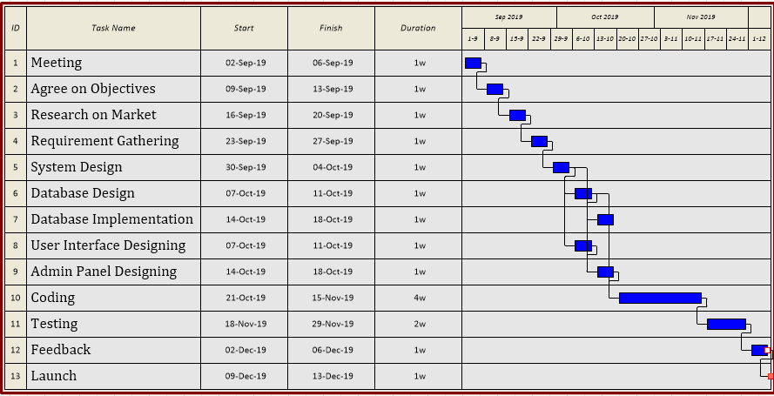

**Risk Analysis:**

* Server security needs to be hacked.
* database must be backup.
* Server all time Up to internet connect.
* Information taken from the customer should be kept secure.
* Database security should be maintained so as not to cause data loss.

## **Conclusion:**

To over come these problem we suggested that reliance fresh take proper strategy for advertising our product as well customer should attract and motivate our chocolate product.